Test Case: tc001_SPX_Dev5_Crear_Solicitud_Articulo_Almacen
Step 1 - Enter username and password and click to button Enter : Credentials Entered
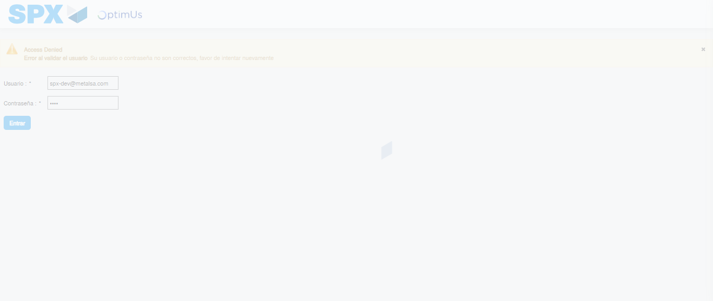Image file-name: QC_Testing-tc001_SPX_Dev5_Crear_Solicitud_Articulo_Almacen-1787941063801

Step 2 - Select to UEN and Access to Request for a New Inventory Item : UEN Correctly selected and Correct access
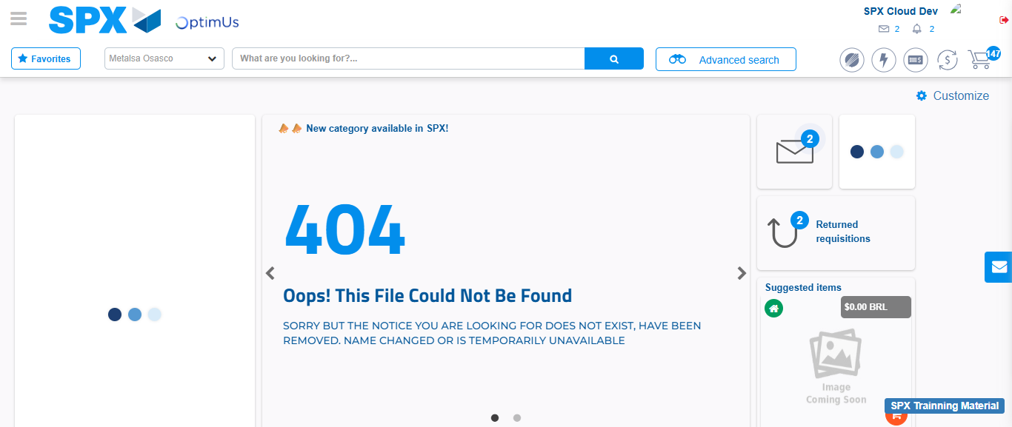Image file-name: QC_Testing-tc001_SPX_Dev5_Crear_Solicitud_Articulo_Almacen-1787941090338

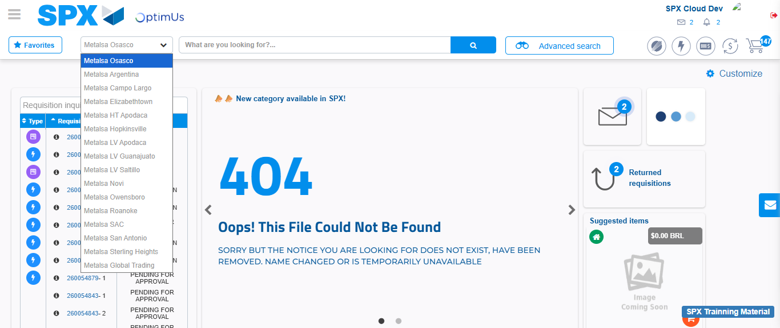Image file-name: QC_Testing-tc001_SPX_Dev5_Crear_Solicitud_Articulo_Almacen-1787941091164

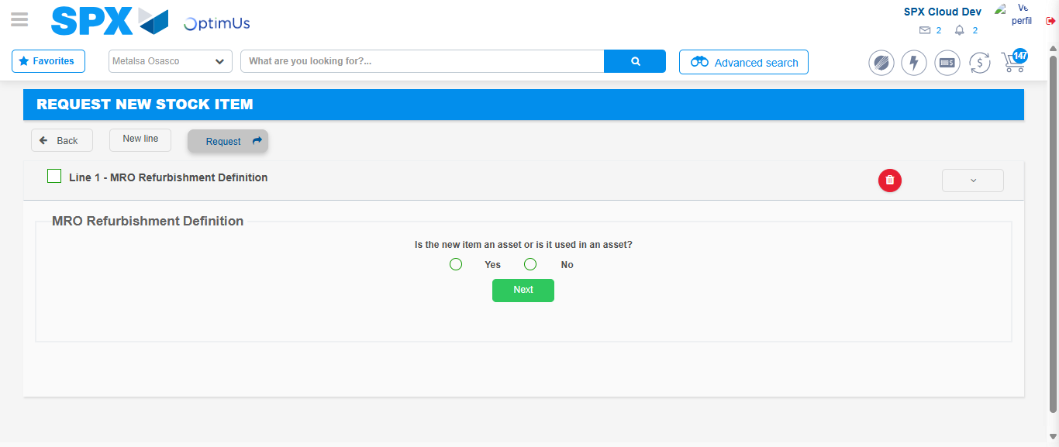Image file-name: QC_Testing-tc001_SPX_Dev5_Crear_Solicitud_Articulo_Almacen-1787941119939

Step 3 - Select options first section : Options seleted correctly
Image file-name: QC_Testing-tc001_SPX_Dev5_Crear_Solicitud_Articulo_Almacen-1787941120258

Image file-name: QC_Testing-tc001_SPX_Dev5_Crear_Solicitud_Articulo_Almacen-1787941120500

Step 4 - Select options at Screen: Options seleted correctly
Image file-name: QC_Testing-tc001_SPX_Dev5_Crear_Solicitud_Articulo_Almacen-1787941120258

Image file-name: QC_Testing-tc001_SPX_Dev5_Crear_Solicitud_Articulo_Almacen-1787941120500

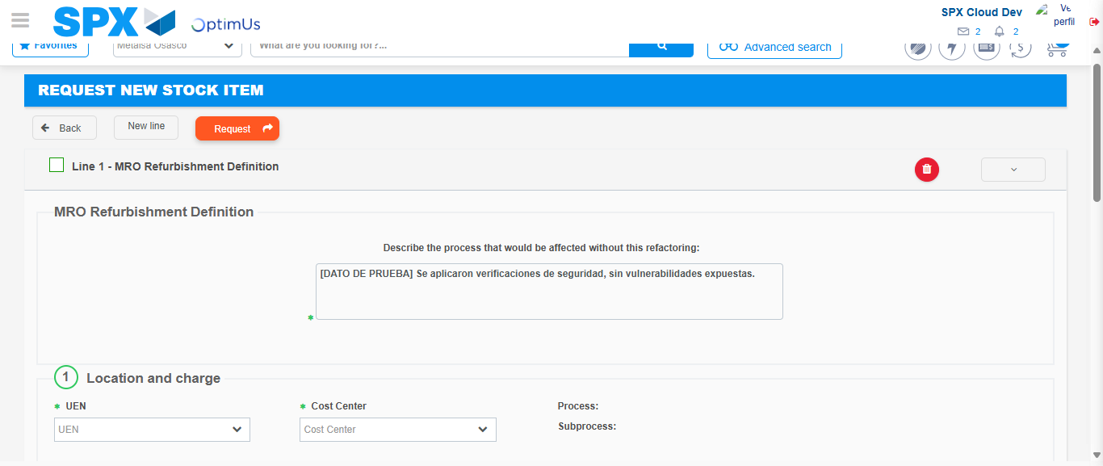Image file-name: QC_Testing-tc001_SPX_Dev5_Crear_Solicitud_Articulo_Almacen-1787941135099

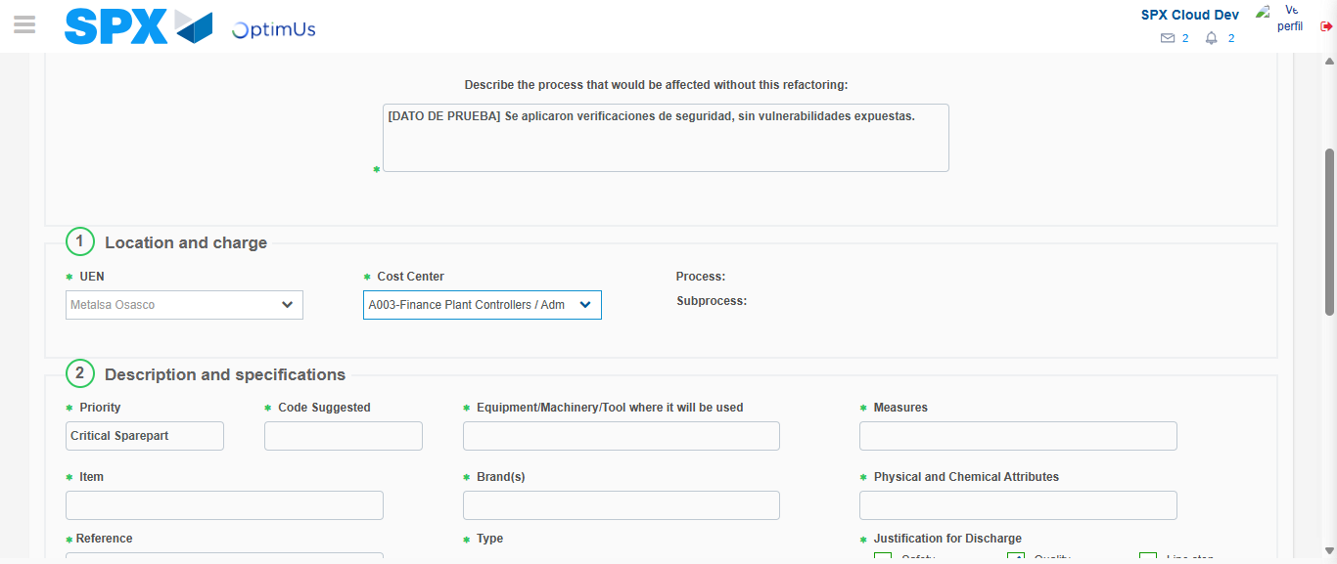Image file-name: QC_Testing-tc001_SPX_Dev5_Crear_Solicitud_Articulo_Almacen-1787941138520

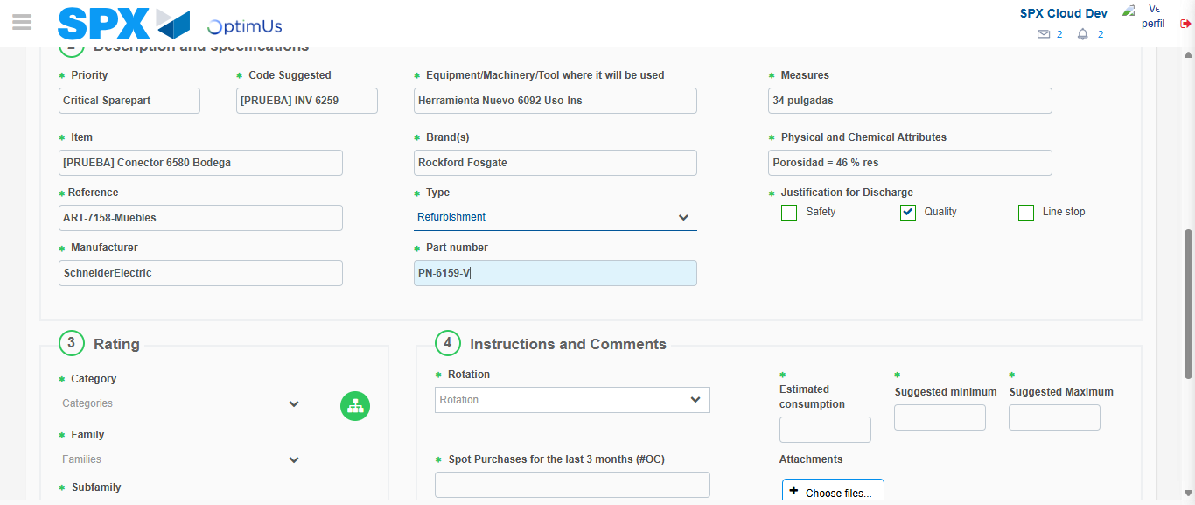Image file-name: QC_Testing-tc001_SPX_Dev5_Crear_Solicitud_Articulo_Almacen-1787941141241

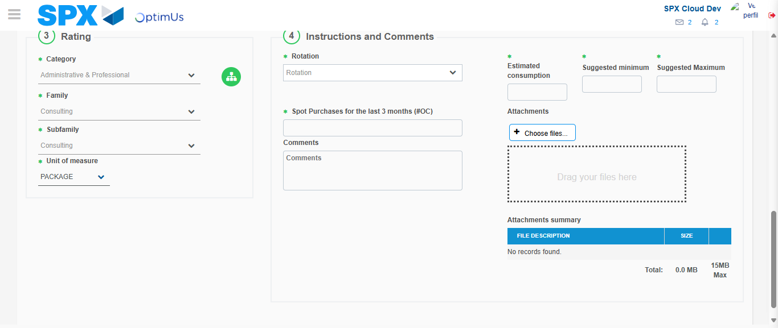Image file-name: QC_Testing-tc001_SPX_Dev5_Crear_Solicitud_Articulo_Almacen-1787941147338

Step 5 - Request New Item : Request Accepted
Image file-name: QC_Testing-tc001_SPX_Dev5_Crear_Solicitud_Articulo_Almacen-1787941090338

Image file-name: QC_Testing-tc001_SPX_Dev5_Crear_Solicitud_Articulo_Almacen-1787941091164

Image file-name: QC_Testing-tc001_SPX_Dev5_Crear_Solicitud_Articulo_Almacen-1787941119939

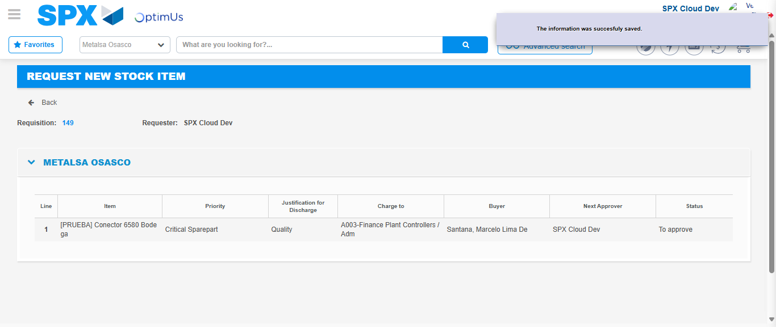Image file-name: QC_Testing-tc001_SPX_Dev5_Crear_Solicitud_Articulo_Almacen-1787941156162

Image file-name: QC_Testing-tc001_SPX_Dev5_Crear_Solicitud_Articulo_Almacen-1787941156446

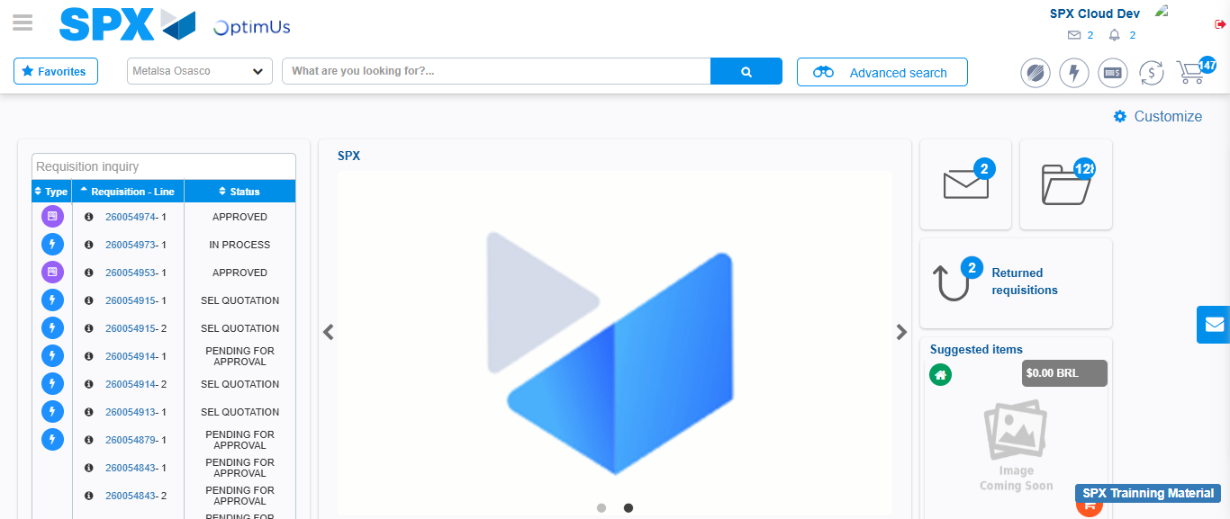Image file-name: QC_Testing-tc001_SPX_Dev5_Crear_Solicitud_Articulo_Almacen-1787941178240

Step 7 - Return to Main Page SPX : Return to Main Page SPX
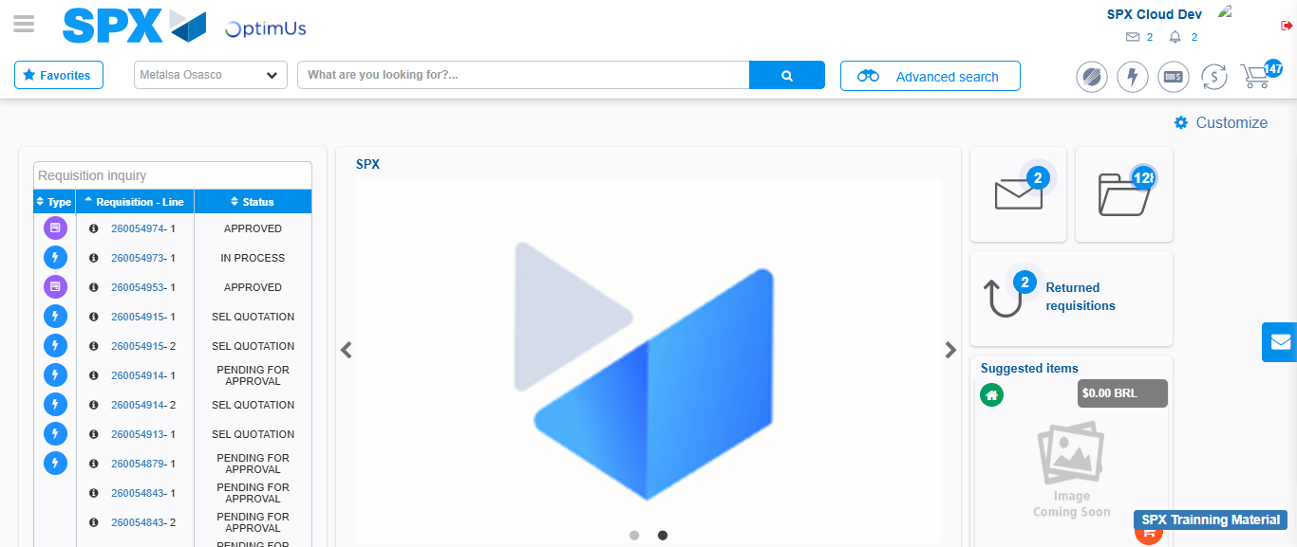Image file-name: QC_Testing-tc001_SPX_Dev5_Crear_Solicitud_Articulo_Almacen-1787941178670

